# **Automatic IFC Archiver**

**Summary**: this code is created with Dynamo (1.3.2 version) in Revit to export IFC files of the model, automatically.

In this section, the required database (which is referred to IFC files archive) is produced and sorted based on the exporting time of IFC files to be utilized in the next step, which is the IFC Logging algorithm explained in the next section. Thus, a piece of algorithm code is developed in Dynamo (1.3.2 version) to periodically generate IFC files during the design authoring phase in Revit. Based on the IFC file size, we set the IFC generation time to be within the range of 60 to 300 seconds, which presumed to be enough to capture BIM files upon every little change (Figure 7). IFC export considered as a time-consuming action especially when it comes to the complex and large BIM models. It might even disrupt the nature of the design authoring process and annoy the designers during the work. To minimize the interruption of IFC archiver algorithm, I categorized the time setting for IFC export based on the file size in the IFC archiving algorithm.

The algorithm has five main blocks. The relationships between blocks are shown in Figure 9. Each block satisfies a sub-objective of RO 1 which are explained as follows:

1. With this block, the time step for the generation of IFC files is set. Also, it provides the “current time” as an input for step 2, 3, and 5.
2. This block export elements’ ID which was selected by designers and the time of selection by them. Elements’ ID and selection time are exported into a CSV file on a real-time basis.
3. The third block is responsible for turning the date and time format to a string format (“MM-DD-YYYY hh-mm-ss” is the naming format used for the exported IFC files)
4. IFC exporter block helped in generation of IFC files. The inputs for this block is folder path (IFC files would be exported in this directory), name of the IFC file (which is the generation date and time), IFC file version (such as "IFC2x2", "IFC2x3", "IFC2x3CV2", "IFC2x2", "IFC4", "IFCBCA", and "IFCCOBIE"), and two Booleans (“wall and column splitting” and “export base quantities”). For the implementation of our case studies, IFC file version and Booleans were set as “IFC2X3”, “False” and “False”, respectively.
5. The last step is created for the elimination of the extra IFC files which were generated. Extra files would be removed if at least one of the following criteria is met: a) When the designer is idle; i.e., when the size of newer IFC file is equal to the older IFC file; b) When the idleness time is less than one hour.

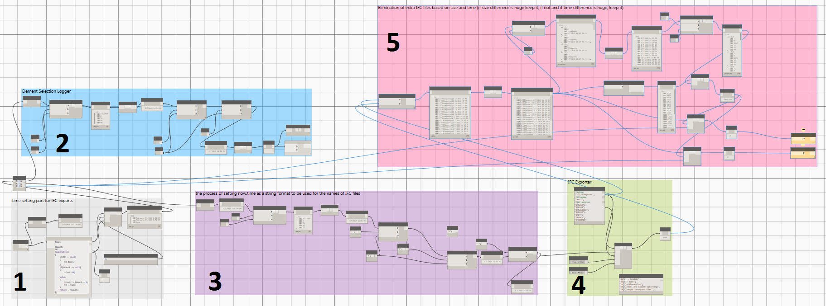

**Figure 8.** IFC archiver algorithm



**Figure 9.** IFC archiver algorithm- the relationship between blocks